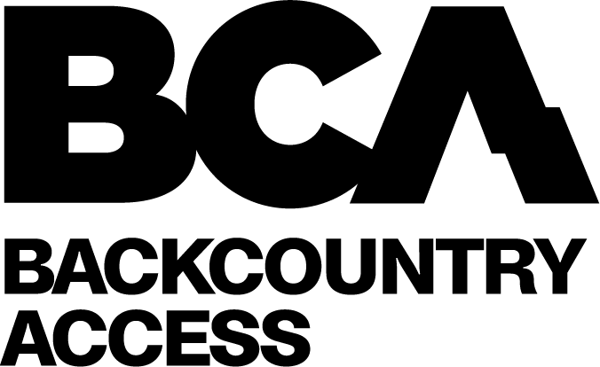

Backcountry Access
Announces New Branding and Brand Logo for 2024

Boulder, CO and Seattle, WA
January 18, 2024

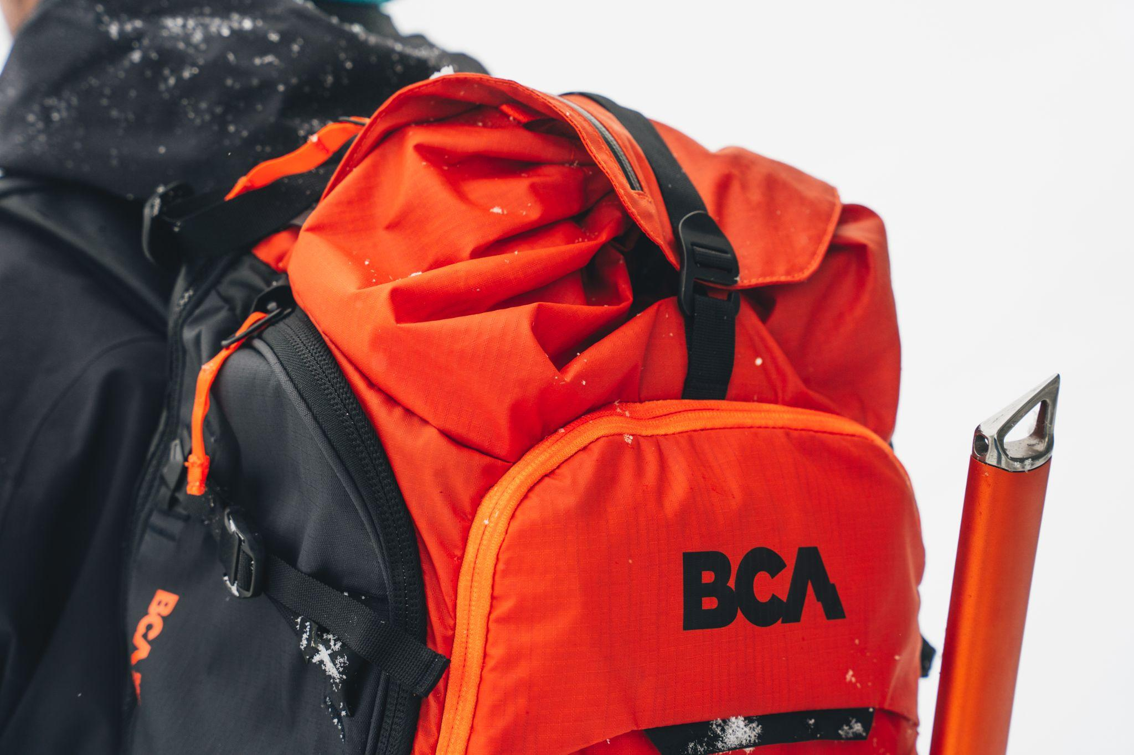

For immediate release:
Backcountry Access Announces New Branding and Brand Logo for 2024

Backcountry Access (BCA) was founded in Colorado in 1994 by hardcore backcountry enthusiasts whose primary objective was to innovate backcountry safety for all. Since its inception, BCA has achieved many landmark “firsts” in product innovation and safety techniques that have made a lasting impact on avalanche safety and backcountry users across the globe. BCA is committed to innovation in technology and driving backcountry safety and education for committed outdoor enthusiasts.



BCA is pleased to announce a new brand design that represents the modern world of backcountry travel, whether human-powered or motorized. With this new look, BCA is both respecting its history and the people who have supported the brand for thirty years and counting, while also showcasing its position as a brand driving global backcountry safety education. The three brand pillars of function, confidence and discipline are woven into the new logo design, look and brand mission. Future brand messaging will encourage those to first prepare before entering the backcountry with proper education and training, inspire backcountry exploration through the new brand storytelling and visuals, and empower backcountry riders with education, product, and the knowledge of how to use it. The logo design represents a blending of a mountain motif, lightning bolt of energy and change, and the iconic BCA letters that have a well-earned association with promoting access and saving lives through reliable, easy-to-use products and consumer education. BCA’s new brand manifesto is a striking reminder: Going into the backcountry isn't exiting the real world, it’s entering it.

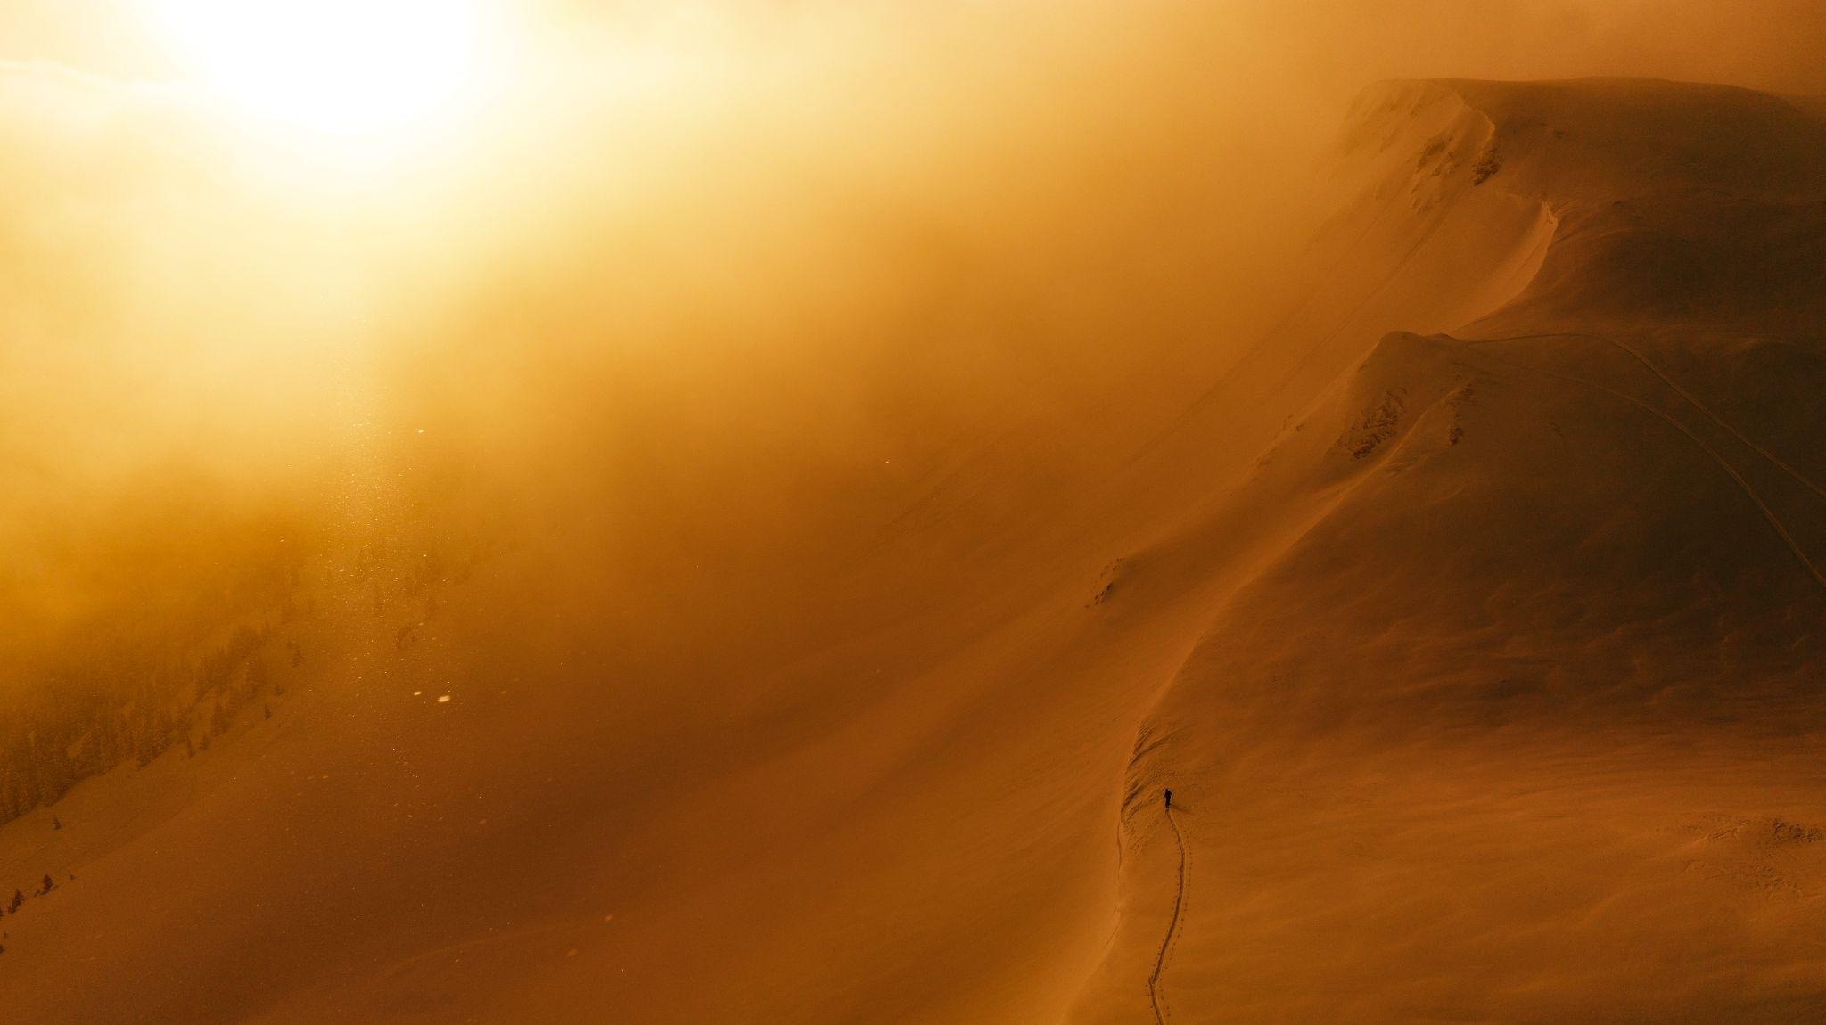

“The updated branding is a new chapter for BCA – modernizing the look of the brand, injecting new energy, and aligning the overall customer relationship with the brand and products. BCA will continue to be a leader in avalanche education advocacy and product innovation, and our goal will remain the same: to promote access and saving lives through reliable, easy-to-use products and consumer education. BCA’s contemporary new branding and messaging are a strong platform for us to share our message and brand vision with the world.” - Steve Christie, BCA Brand Director

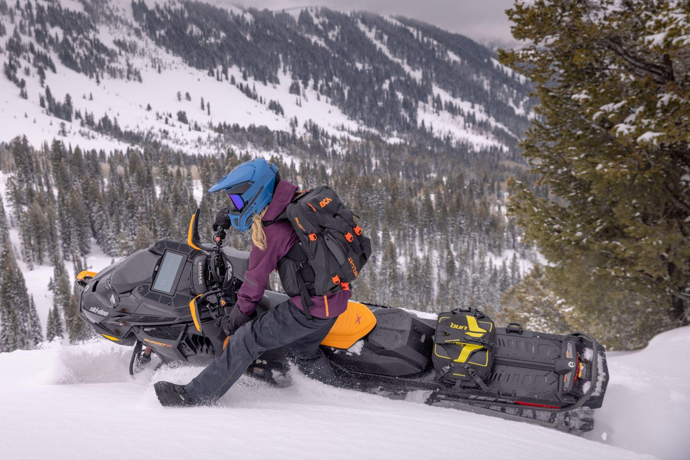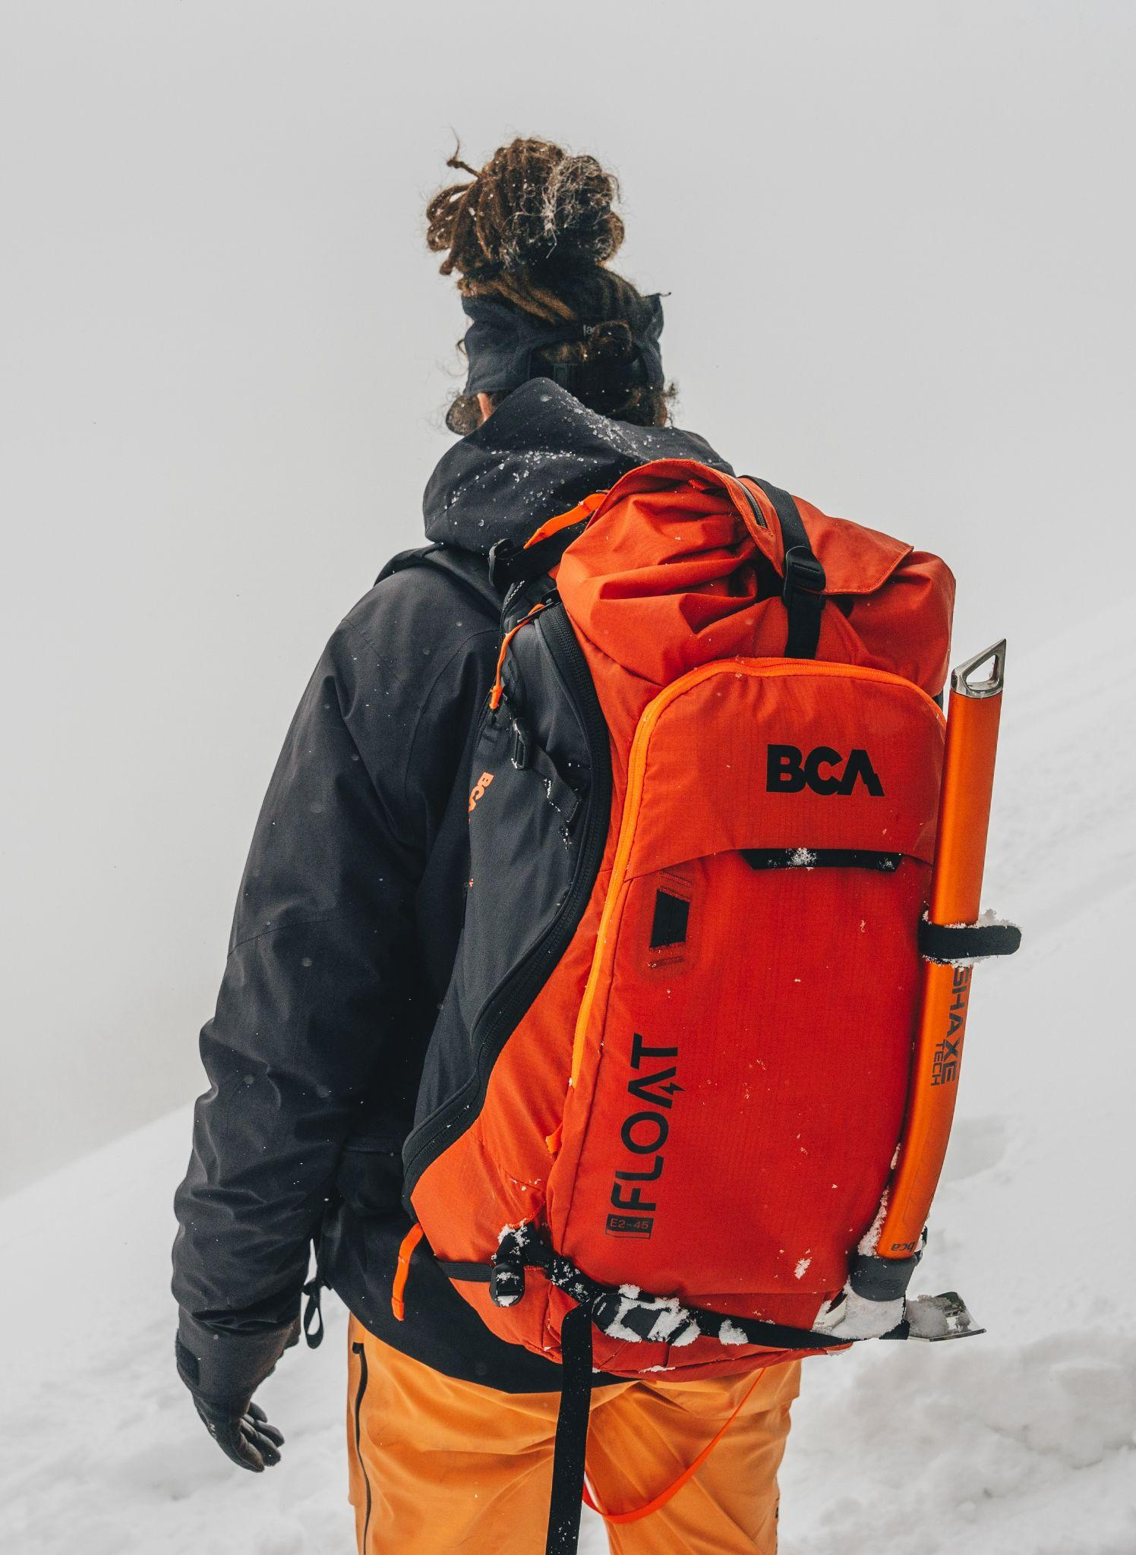

BCA is dedicated to building a world where people can both express and find themselves, a world where people respect the power of nature. To do that, preparation for safe travel in the backcountry happens not the night before, but for years prior. That’s why BCA continues to work hard to provide the tools and education for those interested in exploring safely, because it takes more than physical skill to access the backcountry and return safely.



​​About Backcountry Access
Backcountry Access (BCA) is a leading manufacturer of snow safety equipment, including BCA Tracker™ avalanche transceivers, Float™ avalanche airbags, BC Link™ radios, Stash™ backpacks, MtnPro™ snowmobile gear, Stealth™ avalanche probes, and Dozer™ shovels. BCA is the premier choice of the world’s skiers, snowboarders, snowmobilers, mountain guides and avalanche education professionals. BCA's mission is to be the world’s foremost leader in backcountry safety and education. BCA is dedicated to promoting access and saving lives through reliable, easy-to-use products and consumer education. Backcountry Access stands strong as an important performative brand in the Elevate Outdoor Collective portfolio of the world’s leading winter sports brands.

About Elevate Outdoor Collective
Elevate Outdoor Collective is an alliance of iconic outdoor and winter sports brands with a specialized focus on skiing, snowboarding, snowmobiling and snowshoeing. With each unique brand maintaining its own individual points of view and driving independent innovation, the Collective is fueled with the strength of world-class development facilities and engineers, global distribution channels and committed outdoor lifestyle enthusiasts and experts. Elevate Outdoor Collective brands include: Backcountry Access, K2 Skis, K2 Snowboarding, Marker, Dalbello, Völkl, RIDE Snowboards, LINE Skis, Madshus, Atlas Snow Shoe Co., Tubbs Snowshoes and K2 Skates.

Landing page
backcountryaccess.com/brand

Media asset pack - here

Contact
Press Forward PR
Louise Lintilhac
ll@pressforwardpr.com
802-238-9032

